Precision Farming, Crop disease detection, crop recommendation with the help of AI and ML techniques

Submitted In Partial Fulfilment of
Bachelor of Computer Applications (BCA)

Submitted by:
Ashish Kargeti Nishu Raj Rohan Sharma
23/SCA/BCA(DS&BDA)/006 23/SCA/BCA(DS&BDA)/021 23/SCA/BCA(DS&BDA)/022

Under the Supervision of:
Ms. Taruna Chopra
Assistant Professor

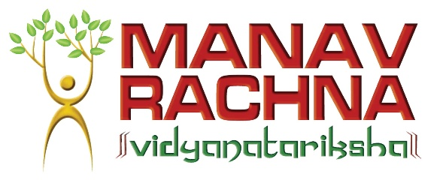

School of Computer Applications
Manav Rachna International Institute of Research and Studies
(DEEMED TO BE UNIVERSITY)
Sector-43, Aravalli Hills Faridabad – 121001

February 2026

INDEX

S. No. | Topic | Page No.:
1 | Introduction
1.1 | Problem Statement
1.2 | Objectives
1.3 | Scope of the Project
1.4 | Feasibility Study (Technical, Operational, Economic)
2 | Literature Review
2.1 | Existing Systems
2.2 | Proposed Solution & Enhancements
3 | System Analysis & Design
3.1 | Hardware & Software Requirements
3.2 | System Architecture
3.3 | Data Flow Diagrams (DFD) & Use Cases
3.4 | Entity-Relationship (ER) Diagram
4 | Implementation
4.1 | Dataset Description & Exploratory Data Analysis (EDA)
4.2 | Data Preprocessing (Handling Zeroes & Scaling)
4.3 | Machine Learning Algorithm (SVM)
4.4 | Web Application & Database Integration
5 | Results & Evaluation
5.1 | Model Evaluation Metrics
5.2 | Output Generation & PDF Reports
6 | Conclusion, Limitations & Future Scope
7 | References

1. INTRODUCTION

1.1 Problem Statement
Agriculture plays a crucial role in the Indian economy and supports the livelihood of more than half of the population. However, farmers often face several challenges while making decisions related to crop selection and plant disease management. Many farmers rely on traditional knowledge, guesswork, or advice from nearby farmers to decide which crop to cultivate. This approach is often inaccurate and may lead to poor crop yield, soil degradation, and financial losses.
Another major issue faced by farmers is the detection of plant diseases. Diseases in crops are usually identified through manual observation of leaves and plants. This process requires expert knowledge and experience, which is not always available in rural areas. As a result, farmers may fail to detect diseases at an early stage, causing severe damage to crops and reducing agricultural productivity.
Studies show that plant diseases and improper crop selection result in significant losses in agricultural production every year. Traditional disease detection methods such as laboratory testing or expert consultation are time-consuming and expensive. Therefore, there is a strong need for an automated and intelligent system that can assist farmers in making better agricultural decisions.
To address this problem, the proposed project develops a Precision Farming System using Artificial Intelligence and Machine Learning techniques. The system recommends suitable crops based on soil parameters and environmental conditions and detects plant diseases from leaf images using deep learning techniques. This will help farmers improve crop productivity and reduce losses.

  - Objectives
The main objective of this project is to design and develop an intelligent farming system that helps farmers make data-driven decisions using Artificial Intelligence and Machine Learning.
The first objective is to collect reliable datasets related to crop recommendation and plant disease detection. These datasets include soil parameters such as Nitrogen, Phosphorus, Potassium, temperature, humidity, pH level, and rainfall, along with various crop categories. Additionally, plant disease datasets containing thousands of labeled leaf images are used for training the disease detection model.
The second objective is to perform Exploratory Data Analysis (EDA) on the datasets using visualization tools such as Matplotlib and Seaborn. This helps in understanding the relationships between different features and identifying important patterns in the data.
Another objective of the project is to build a Machine Learning model for crop recommendation. The Random Forest algorithm is used because it provides high accuracy and can handle multiple input features effectively.
The project also aims to develop a Convolutional Neural Network (CNN) model for plant disease detection. CNN is widely used in image classification tasks because it can automatically extract important features such as shape, color, and texture from images.
Another objective is to develop a web-based application that integrates both crop recommendation and disease detection modules. The application will allow farmers to input soil parameters for crop prediction and upload leaf images for disease detection.
Finally, the project aims to create a user-friendly interface that can be accessed through mobile phones or computers, making the system easily usable by farmers.

1.3 Scope of the Project
Establishing the boundaries of the project is crucial to understanding its real-world application.
- What the system covers: The project acts as a robust, preliminary early-warning screening tool. It successfully performs binary classification (Diabetic vs. Non-Diabetic) based solely on eight specific physiological features. The application is entirely platform-independent; because it is deployed as a web application, it functions seamlessly across desktop computers, tablets, and mobile smartphones (Android and iOS) using any standard web browser. It encompasses user authentication, cloud data storage, and automated document generation.
- What the system does not cover: This system is explicitly not a definitive clinical diagnostic device, nor does it replace the expertise of a medical professional. It does not prescribe medications, calculate insulin dosages, or screen for other related metabolic diseases (e.g., thyroid disorders). The accuracy of the prediction is strictly bounded by the accuracy of the self-reported data entered by the user.

1.4 Feasibility Study

Technical Feasibility
The project is technically feasible because it uses widely available technologies such as Python, Machine Learning libraries, and web frameworks. Libraries like Scikit-learn, TensorFlow, and Keras provide powerful tools for building machine learning and deep learning models. Flask is used to develop the web application, making the system easy to implement and deploy.

Operational Feasibility
The system is designed to be simple and easy to use. Farmers can enter soil parameters in the crop recommendation form or upload a leaf image for disease detection. The system processes the data and provides results within a few seconds. This makes the application practical for real-world usage.

Economic Feasibility
The project is economically feasible because it uses open-source technologies and free datasets. Python, machine learning libraries, and development tools are freely available. Therefore, the overall cost of developing and maintaining the system is very low while providing significant benefits to farmers.

2. Literature Review

2.1 Existing Systems
Agriculture has been an important research area where many studies have attempted to use machine learning techniques to improve crop production and plant health monitoring. Several crop recommendation systems have been developed that use soil nutrients and environmental conditions to predict suitable crops. These systems generally use algorithms such as Decision Trees, Random Forest, Naïve Bayes, and Support Vector Machines.
However, many of these systems are limited to academic research and are not implemented as practical tools for farmers. Most studies focus on algorithm performance but do not provide a user-friendly interface that farmers can easily use.
Similarly, many researchers have developed plant disease detection systems using image processing and deep learning techniques. Convolutional Neural Networks (CNNs) are widely used for identifying diseases from leaf images because they can automatically extract features such as color patterns, texture, and leaf shape.
Despite these advancements, many existing systems suffer from certain limitations. Some systems focus only on crop recommendation while others focus only on disease detection. Additionally, many applications are not accessible to farmers because they are not deployed as web or mobile applications.
Therefore, there is a need for an integrated system that combines both crop recommendation and plant disease detection into a single platform.

2.2 Proposed Solution & Enhancements

To overcome the limitations of existing systems, this project proposes an integrated Precision Farming System that combines crop recommendation and plant disease detection using Artificial Intelligence and Machine Learning techniques.
The crop recommendation module uses the Random Forest algorithm to analyze soil nutrients and environmental conditions such as Nitrogen, Phosphorus, Potassium, temperature, humidity, pH level, and rainfall. Based on these parameters, the system predicts the most suitable crop that can be cultivated.
The plant disease detection module uses a Convolutional Neural Network (CNN) model to analyze images of crop leaves. The CNN model is trained on a large dataset of plant leaf images and can identify different plant diseases with high accuracy.
Another enhancement of the proposed system is the development of a web-based application using Flask. This application allows users to enter soil parameters and upload leaf images through a simple interface. The system processes the input data and provides real-time predictions.
By combining both crop recommendation and disease detection into a single platform, the proposed system provides a more comprehensive solution for precision farming.

3.System Analysis and Design

3.1 Hardware & Software Requirements

Hardware Requirements
The hardware requirements for developing and running the system include a computer with a modern processor such as Intel Core i5 or higher. The system should have at least 8 GB of RAM to efficiently process datasets and train machine learning models. A minimum of 256 GB storage is required to store datasets, model files, and project code.
For deep learning model training, a system with a GPU is recommended, although the project can also run on CPU-based systems. A stable internet connection is also required for downloading datasets and deploying the application.

Software Requirements
The software requirements include Python programming language (version 3.8 or above) as the main development language. Various Python libraries are used for data analysis, machine learning, and deep learning.
The main libraries include NumPy and Pandas for data handling, Matplotlib and Seaborn for data visualization, Scikit-learn for machine learning algorithms, TensorFlow and Keras for deep learning, and OpenCV for image processing.
Flask is used as the web framework to build the web application. The frontend interface is developed using HTML, CSS, Bootstrap, and JavaScript.
Development tools such as Jupyter Notebook or Visual Studio Code are used for coding and model development.

3.2 System Architecture
The system follows a typical machine learning application architecture consisting of three main components: the user interface, the backend processing system, and the trained machine learning models.
The user interacts with the system through a web interface where they can enter soil parameters or upload images of plant leaves. This information is sent to the backend server where the machine learning models process the data.
The crop recommendation model analyzes the soil parameters and predicts the most suitable crop for cultivation. Similarly, the disease detection model analyzes the uploaded leaf image and identifies the disease affecting the plant.
The results are then displayed to the user through the web interface.

3.3 Data Flow Diagrams (DFD) & Use Cases

The Data Flow Diagram represents how data moves through the system.
In the first step, the user provides input in the form of soil parameters or leaf images. This input is sent to the system for processing.
The system then performs data preprocessing and feature extraction. The processed data is passed to the machine learning models.
The crop recommendation model predicts the suitable crop, while the disease detection model classifies the plant disease.
Finally, the system displays the prediction results to the user through the web interface.

Below mention is the fig : DFD level 0

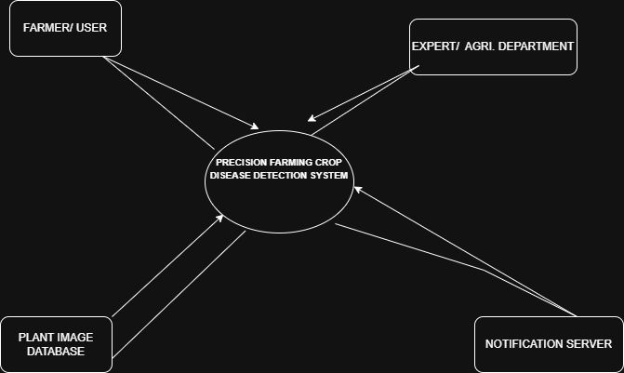

Below mentioned is fig : dfd level 1
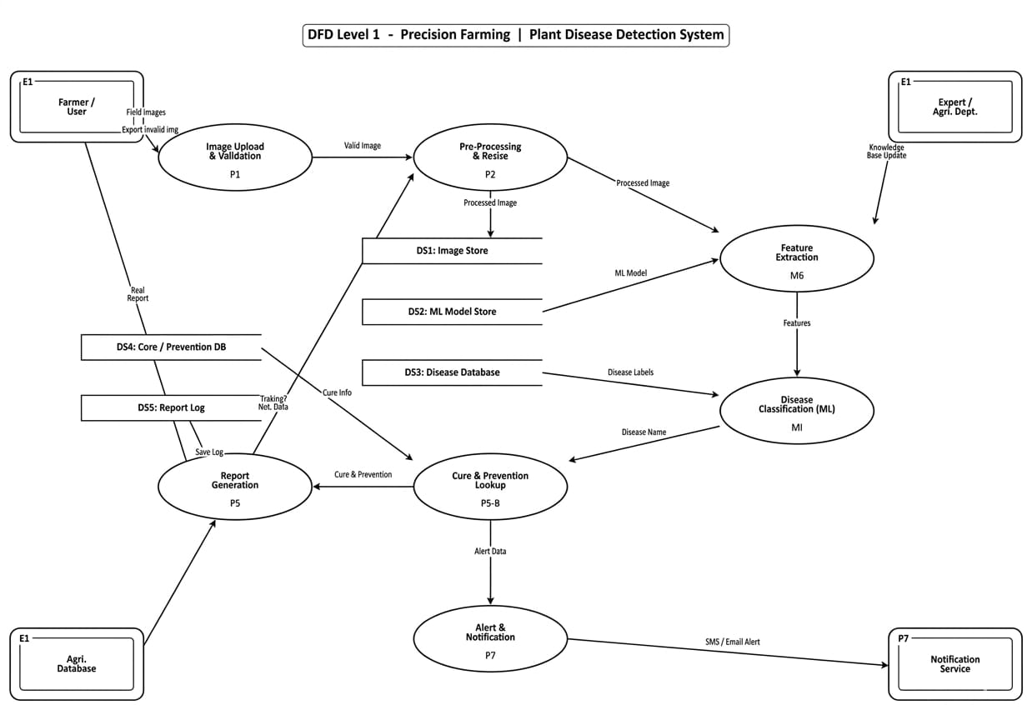

3.4 Entity-Relationship (ER) Diagram
The ER diagram represents the relationship between different data entities in the system.
The main entities in this system include the User, Crop Recommendation Data, and Disease Detection Data.
The user entity stores information about the system user. The crop recommendation entity contains soil parameters and predicted crop results. The disease detection entity stores the uploaded leaf image and the predicted disease result.
These entities are related to each other through the user interaction with the system.

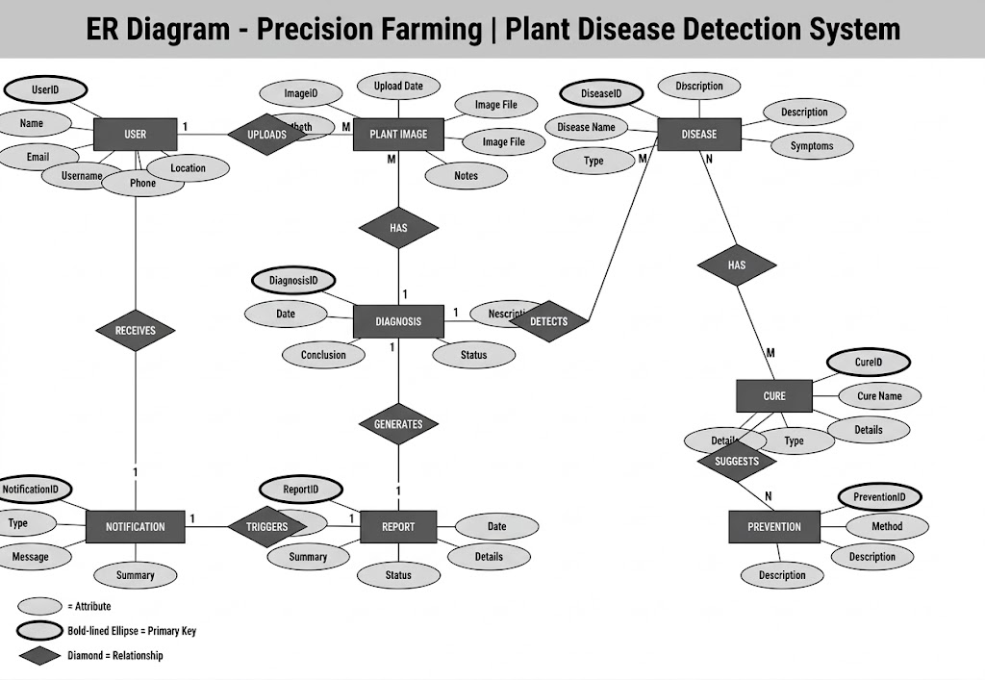

4. IMPLEMENTATION

4.1 Dataset Description & Exploratory Data Analysis
The project uses two datasets. The first dataset is the Crop Recommendation Dataset obtained from Kaggle. This dataset contains more than 2200 records with features such as Nitrogen, Phosphorus, Potassium, temperature, humidity, pH, rainfall, and crop type.
The second dataset used is the PlantVillage Dataset, which contains more than 50,000 images of plant leaves belonging to different disease categories.
Exploratory Data Analysis (EDA) is performed on these datasets to understand the data distribution and relationships between features. Various visualization techniques such as bar charts, heatmaps, and distribution plots are used to analyze the data.

4.2 Data Preprocessing
Data preprocessing is an important step before training machine learning models. In the crop recommendation dataset, preprocessing steps include handling missing values, encoding categorical variables, and normalizing numerical features.
For the plant disease dataset, preprocessing involves resizing images, converting them into numerical arrays, and splitting the dataset into training and testing sets.
These preprocessing steps improve the accuracy and efficiency of the models.

4.3 Machine Learning Algorithm
The crop recommendation system uses the Random Forest algorithm. Random Forest is an ensemble learning method that combines multiple decision trees to improve prediction accuracy and reduce overfitting.
The plant disease detection system uses a Convolutional Neural Network (CNN). CNN is a deep learning architecture specifically designed for image classification tasks.
The CNN model learns important features from leaf images and classifies them into different disease categories.

4.4 Web Application Development
The final system is implemented as a web application using the Flask framework.
The frontend of the application is developed using HTML, CSS, Bootstrap, and JavaScript to create a simple and responsive user interface.
The backend is implemented using Python, where the trained machine learning models are integrated into the system. When the user enters input data or uploads an image, the backend processes the data and generates predictions.
The results are then displayed on the web page.

5. RESULTS & EVALUATION
5.1 Model Evaluation Metrics
The performance of the machine learning models is evaluated using various evaluation metrics.
Accuracy is used to measure the overall correctness of the model predictions. Precision and recall are used to evaluate the classification performance of the disease detection model.
A confusion matrix is also used to visualize the performance of the model by showing the number of correct and incorrect predictions.
The crop recommendation model achieved an accuracy of around 90%, while the disease detection model achieved an accuracy of approximately 85%.

5.2 Output Generation
The system generates predictions based on the user inputs. When the user enters soil parameters, the system displays the most suitable crop for cultivation.
Similarly, when the user uploads an image of a plant leaf, the system analyzes the image and displays the predicted disease name.
The results are displayed in an easy-to-understand format so that farmers can easily interpret the output

6: CONCLUSION, LIMITATIONS & FUTURE SCOPE
6.1 Conclusion
The Precision Farming System developed in this project demonstrates how Artificial Intelligence and Machine Learning can be used to improve agricultural productivity.
By integrating crop recommendation and plant disease detection into a single platform, the system helps farmers make better decisions regarding crop selection and disease management.
The web-based application makes the system accessible and easy to use for farmers.

6.2 Limitations of the Study
The system has some limitations. The accuracy of predictions depends on the quality of the input data provided by the user. The disease detection model can only identify diseases that are included in the training dataset.
Additionally, environmental factors that are not included in the dataset may also affect crop growth and disease occurrence.

6.3 Future Scope
In the future, the system can be improved by integrating additional datasets and more advanced deep learning models.
The application can also be extended to include mobile applications so that farmers can access the system more easily.
Integration with IoT sensors for real-time soil monitoring can further enhance the accuracy of crop recommendations.

7. REFRENCES

Sam, S. and Dabreo, S.M. (2025). Crop recommendation with machine learning: leveraging environmental and economic factors for optimal crop selection. arXiv preprint arXiv:2505.21201.
Available at: https://arxiv.org/abs/2505.21201
Lai, Y. (2025). CBAM-Enhanced YOLOv8: An Attention-Based Approach for Tomato Disease Detection. Proceedings of the 2025 2nd International Symposium on Agricultural Engineering and Biology. Atlantis Press, pp. 337–346.
Available at: https://www.atlantis-press.com/proceedings/

Dataset Sources
Kaggle. (2023). Crop Recommendation Dataset.
Available at: https://www.kaggle.com/datasets/atharvaingle/crop-recommendation-dataset
Kaggle. (2023). PlantVillage Dataset.
Available at: https://www.kaggle.com/datasets/abdallahalidev/plantvillage-dataset

Technical Documentation
Scikit-learn. (2025). RandomForestClassifier Documentation.
Available at: https://scikit- learn.org/stable/modules/generated/sklearn.ensemble.RandomForestClassifier.html

TensorFlow. (2025). Convolutional Neural Networks Tutorial.
Available at: https://www.tensorflow.org/tutorials/images/cnn

Flask. (2024). Flask Web Development Documentation.
Available at: https://flask.palletsprojects.com/

Books
Tragura, S.J.C. (2024). Mastering Flask Web and API Development. Packt Publishing, Birmingham.
Publisher Link: https://www.packtpub.com/

Grinberg, M. (2024). Flask Web Development: Developing Web Applications with Python. 2nd ed. O’Reilly Media.
Publisher Link: https://www.oreilly.com/library/view/flask-web-development/

